**Exploratory Analysis**

1. What is the type of data you see in the dataset: Continuous or Categorical?

Categorical data

1. Which month and year had highest crimes

In the 7th month of the year 2019, we have highest crimes 24828

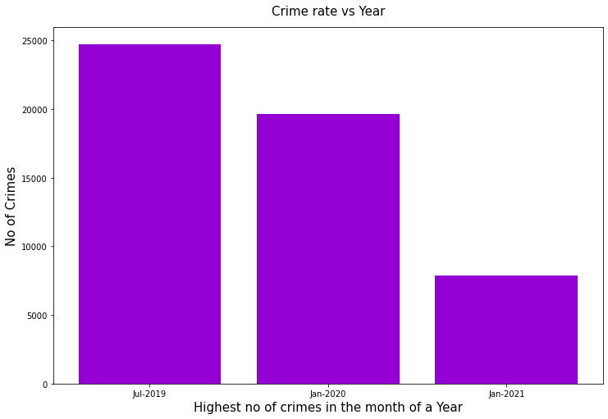

1. What types of crimes are most common?

These are the top 5 crimes that are common

THEFT 104630

BATTERY 92325

CRIMINAL DAMAGE 52444

ASSAULT 39525

DECEPTIVE PRACTICE 36426

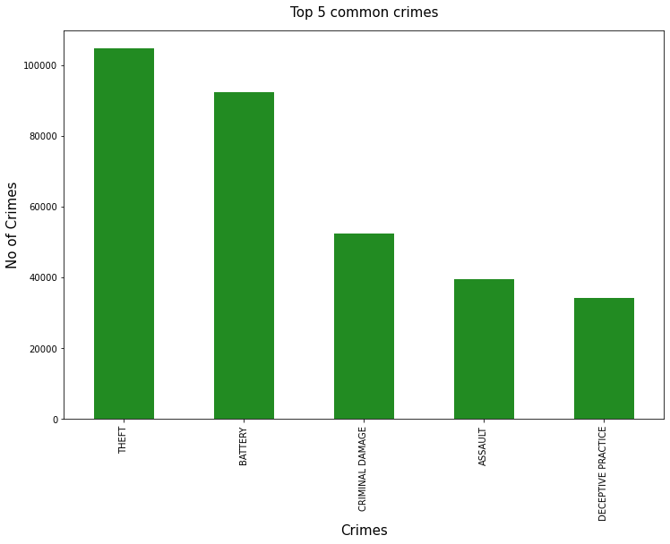

1. Where are different types of crimes most likely to occur?

Non domestic crimes are most likely to occur

1. How many domestics’ assaults are there?

84419

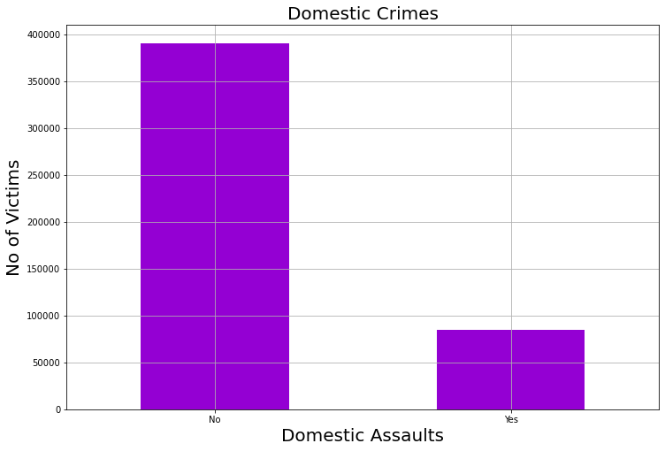

1. Which crime has highest arrests ?

NARCOTICS – 22573

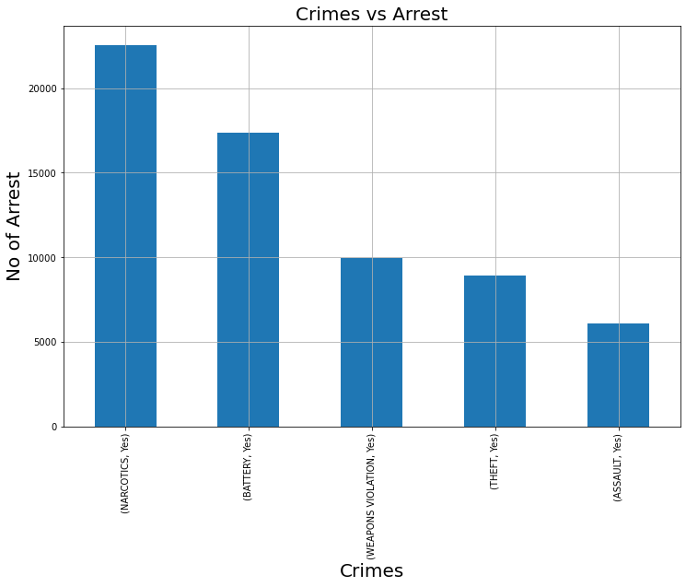

1. Which fields are important for analysis?

Domestic, Location, Primary Type, Hour, day and month.